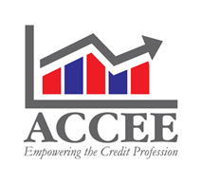
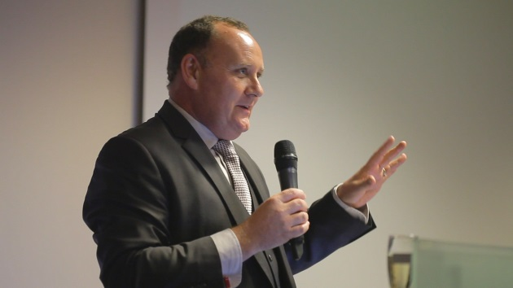

Mark Harrison is the founder and CEO of ACCEE Association of Credit for Central and Eastern Europe based in the Czech Republic.

Mark is a Fellow of the UK Institute of Credit Management and one of a small number to hold a BA Honours degree in Credit Management. Mark has been involved in operational credit management for more than 25 years at a number of multi-nationals including TNT, Volvo, Terex, Norgren and PPG.
Mark has a number of years experience in the field working for a variety of multinationals worldwide. He has a degree in Credit Management.

ACCEE carry out a variety of roles in the Credit industry from educating, training and also a number of networking events to ensure that Credit becomes a recognised profession.

